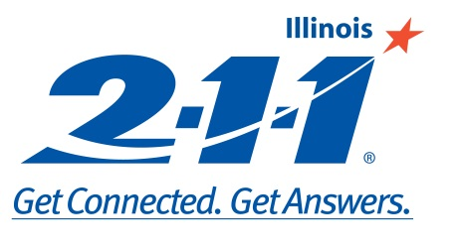

United Way 2-1-1 Report
Champaign County
October - December 2013
Submitted by: Karen Zangerle, Executive Director, PATH, Inc.

n=133¹

n=185²
n=2
Champaign County
Abandoned Calls³ | Escape Calls⁴ | Non-Transaction Calls⁵
0 | 0 | 4
¹ Top Ten Reasons for Contact – there can be more than one reason per call
² Top Ten Referrals – calls with resulting referrals usually receive more than one referral
³ Abandoned Calls are calls that reach the center but are not answered.
⁴ Escape Calls occur when a call center specialist accidently begins to log a call but cancels the log.
⁵ Non-Transaction Calls are hang-ups or wrong numbers.

